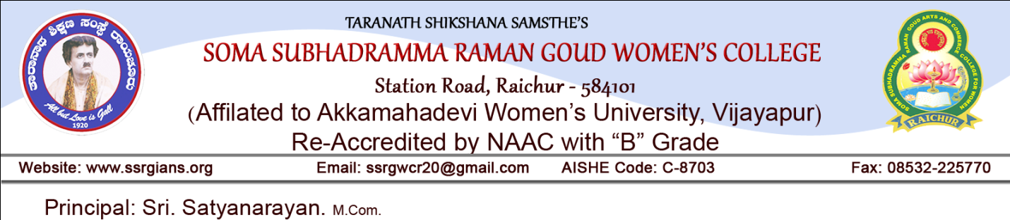 Date: 23-08-2022

INSTITUTIONAL CALENDER OF EVENTS FOR THE YEAR 2021-22
I Sem, III Sem, V Sem(Odd Semester)

1. Admission process | 23rd August 2021
2. October 2021 | Re-opening of the college – Odd Semester – 18th October Commencement of classes - I, III & V Sem.
3. November 2021 | a) Orientation Programme for B.A, B.Com, & B.S.W 1st Sem Students in November 1st week.  b) Inauguration of N.S.S. Activities for the year 2021 in November 3rd week
4. December 2021 | a) I Internal Test in December 1st week.  b) Celebration of Gandhi Jayanthi on 02 Oct,  c) Parents’ Meet in December 2nd week.  d) Alumni Meet in December 3rd week.  c) Communication Skill- Programme for B.A, B.Com & B.S.W IV Sem Students in December 4th week.
5. January 2022 | a) Celebration of Swami Vivekanad Jayanthi on 12-01-2022  b) II Internal Test in January 3rd week.  c) Celebration of National Voters Day on 25-01-2022.
6. February 2022 | a) Completion of syllabi.  b) Last working day of odd Sem on 12-02-2022.

PRINCIPAL

Date: 04-05-2022

INSTITUTIONAL CALENDER OF EVENTS FOR THE YEAR 2021-22
II Sem, IV Sem, VI Sem(Even Semester)

1. May 2022 | Re-opening of the college, 04-05-2022
2. June 2022 | b) NSS Special Camp in June IInd week.
2. July 2022 | a) Industrial visit in July 2nd week.  b) Ist Internal Tests in July 3rd week.  c) Historical visit (Tour) July 4th week.
3. August 2022 | a) Career guidance programme for B.A & B.Com VI sem Students in August 1st week.  b) Talents’ Day Preparation in August 2nd week.  c) II Internal Test for II, IV and VI semester in August 3rd week..  d) Talents ’Day Celebration & Valedictory function of Sports Activities in August last week
4. September 2022 | - Completion of Syllabi and Examination preparation.  - Last working day 17-09-2022

PRINCIPAL

